# 13. ReactJS-HOL

**Objectives**

* Explain various ways of conditional rendering
* Explain how to render multiple components
* Define list component
* Explain about keys in React applications
* Explain how to extract components with keys
* Explain React Map, map() function

In this hands-on lab, you will learn how to:

* Implement conditional rendering in React applications

**Prerequisites**

The following is required to complete this hands-on lab:

* Node.js
* NPM
* Visual Studio Code

**Notes**

Estimated time to complete this lab: **60 minutes.**

Create a React App named “bloggerapp” in with 3 components.

1. Book Details
2. Blog Details
3. Course Details

Implement this with as many ways possible of Conditional Rendering.

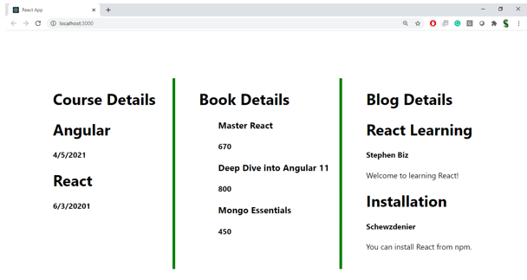

## App.jsx:

import Bookdetails from "./Bookdetails";

import Coursedetails from "./Cousrsedetails";

import Blogdetails from "./Blogdetails";

function App() {

  return (

    <>

    <div style={{justifyContent:"center",display:"flex", paddingTop:"50px"}}>

    <div>

      <Coursedetails/>

    </div>

    <div>

      <Bookdetails />

    </div>

    <div>

      <Blogdetails/>

    </div>

    </div>

    </>

  );

}

export default App;

## Bookdetails.jsx:

function Bookdetails() {

  const books = [

    { id: 101, bname: "Master React", price: 670 },

    { id: 102, bname: "Deep dive into Angular", price: 800 },

    { id: 103, bname: "Mongo Essentials", price: 450 },

    { id: 104, bname: "Spring Boot", price: 900 },

  ];

  const bookdet = books.map((book) => (

    <div key={book.id}>

      <h3>{book.bname}</h3>

      <h4>{book.price}</h4>

    </div>

  ));

  return (

  <div style={{ borderLeft: "4px solid green", paddingLeft: "20px"  }}>

    <div style={{margin:"10px"}}>

    <h1>Book Details</h1>

    {bookdet}

    </div>

    </div>

  );

}

export default Bookdetails;

## Blogdetails.jsx:

function Blogdetails(){

    const data=[

        {name:"React Learning",author:" Stephen Biz" , abstract:"Welcome to learning React!"},

        {name:"Installation",author:"Schewzdenier" , abstract:"You can install react from npm"},

        {name:"Spring Boot",author:"Kaushic" , abstract:"Welcome to learning Spring Boot!"}

    ];

    const dataarr=data.map((blog)=>(

        <div>

            <h1>{blog.name}</h1>

            <h2>{blog.author}</h2>

            <h3>{blog.abstract}</h3>

        </div>

    ))

    return(

        <div style={{ borderLeft: "4px solid green", paddingLeft: "20px" }}>

              <div style={{margin:"10px"}}>

            <h1>Blog Details</h1>

            {dataarr}

        </div></div>

    )

}

export default Blogdetails;

## Coursedetails.jsx:

function Coursedetails(){

    const data=[

        {name:"Angular",date:"4/5/2021"},

        {name:"React",data:"6/3/2021"},

        {name:"SpringBoot",date:"2-8-2025"}

    ];

    const coursedet=data.map((course)=>(

            <div>

                <h1>{course.name}</h1>

                <div>{course.date}</div>

            </div>

    ))

    return(

<div>

              <div style={{margin:"10px"}}>

            <h1>Course Details</h1>

            {coursedet}

        </div></div>

    )

}

export default Coursedetails;

## Output:

